**145. Using a Load Balancer for a Stable Domain**

[**https://www.udemy.com/course/docker-kubernetes-the-practical-guide/learn/lecture/22626609#questions/18350908**](https://www.udemy.com/course/docker-kubernetes-the-practical-guide/learn/lecture/22626609#questions/18350908)

[omer](https://www.udemy.com/user/omer-moaz/)

5 upvotes**5**

4 months ago

It took me 2 days to find the exact issue and solution for this problem. I advise @Maximilianto share this solution in as a video update.

**Follow the steps if you are facing issues with**

1**.**Follow steps in current lecture named**"Using a Load Balancer for a Stable Domain"**

2. Mongo db image doesn't allow authentication as the tutorial is based on an older image on Docker hub so instead using image "**mongo**" use "**mongo:3.6.19-xenial**"

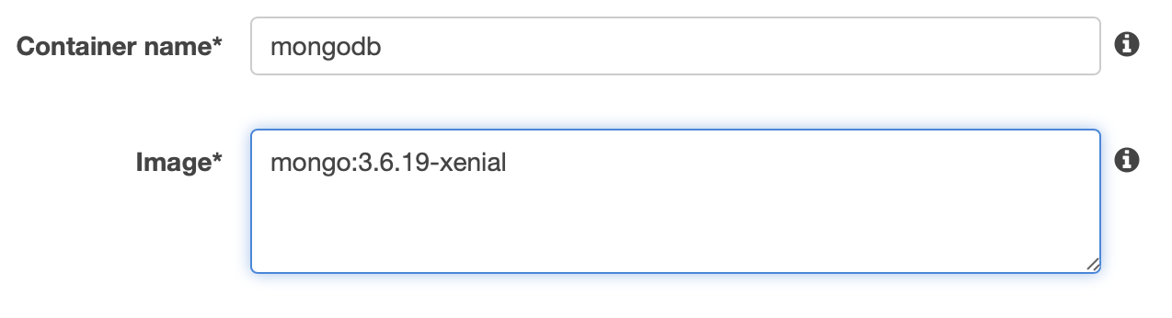

3. goals-backend container expects that the mongoDB server is already started. For this **edit goals-backend container**and add "**Startup Dependancy Ordering**" as follows

**container name: "mongodb"**

**condition: "start"**

